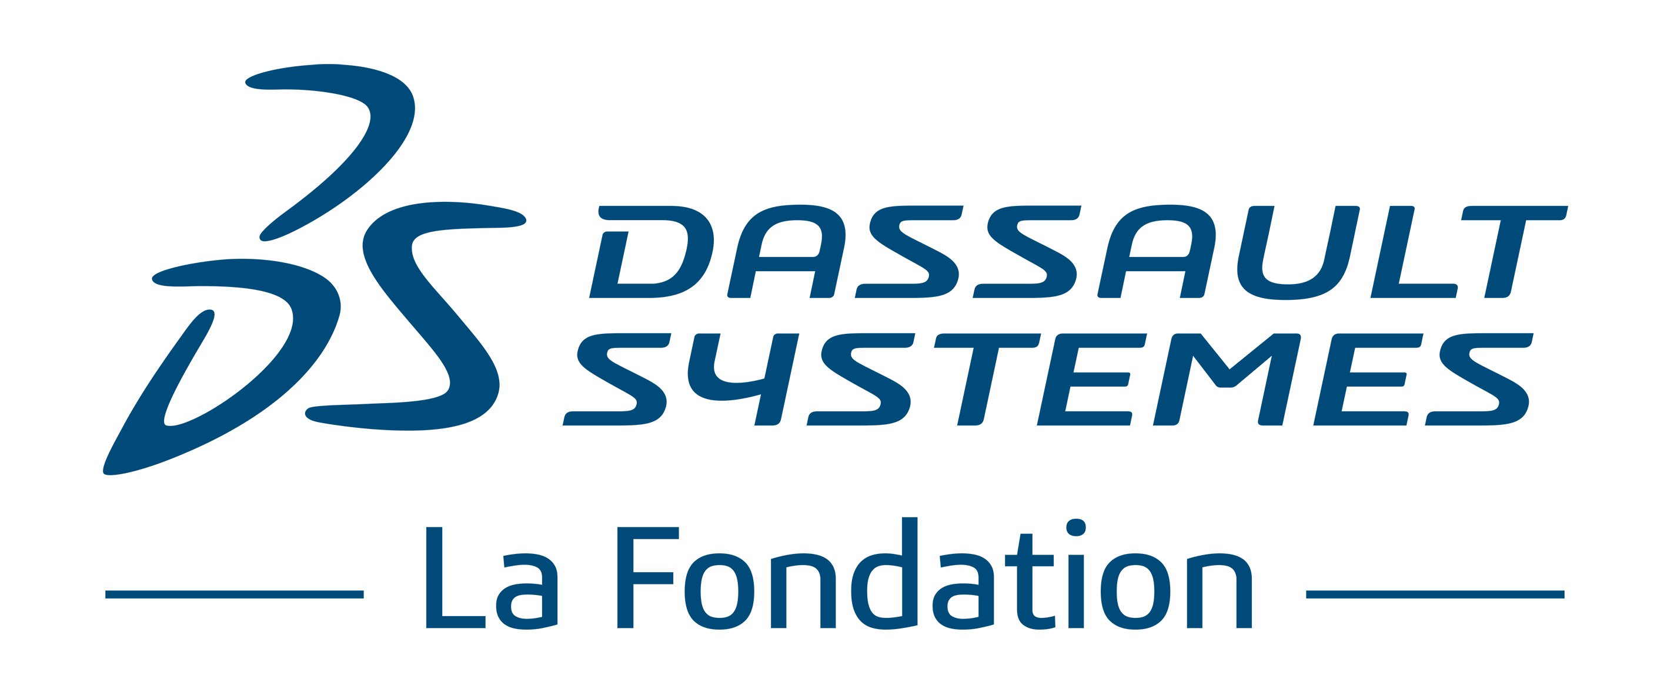

INDIA APPLICATION FORM
For funding request to “Dassault Systèmes Foundation”

Requesting Organization’s Name

Project Title

Reminder of the criteria for eligibility

The project must:

- Be in agreement with Dassault Systèmes Foundation ’ objective:

By-Laws article 2.1: Purpose

The Fund‘s purpose is to organize and support all general interest initiatives that aim to provide a wide public with an access to the capabilities of 3D ("three dimensional") technologies in the areas of education and teaching, culture and art, and scientific and technological research, as well as to encourage and to participate in all initiatives in these fields, either directly or indirectly.

The Fund seeks to:
- actively contribute towards transforming teaching and towards educational innovation, in particular through 3D experiences and contents;
- spark young people’s interest in engineering careers, science and digital technology;
- provide schools and universities with more access to 3D technologies, contents, and simulation;
- encourage technological and scientific research;
- help conserve, preserve and enhance mankind’s intellectual heritage.

- Being a part of the sponsorship includes:

- The focus on a non-profit and non-commercial project recognized by the public interest

- The support of a recognized organization of general interest capable of receiving the patronage, and whose headquarters are located in India.

- For an organization seeking sponsorship in India, such organization should also be located in India and should have all the necessary registrations as per Regulations listed in Annexure 2, as and when applicable:

The following will also be considered:

- the nature of the impact and leverage of the proposed action

- the character of its innovative and inspirational model

- lasting impact of the project

- its ability to integrate and value diversity, including gender diversity

- its presence in India

- Spirit of sharing

- its ability to mobilize employees of Dassault Systèmes

- Its assessable nature

Presentation of the organization requesting the participation of Dassault Systèmes Foundation

Organization’s name

Name and title of the Manager

Legal Status

Mission

Organization Formation Date

Financial resources

Geographical coverage

Number of employees

Number of volunteers

Are 3DS employees already involved?

Purpose of the applying organization

- Project Details

Project Title

Name and title of the project manager

Address

Phone Number
Cell Phone

E-mail

Project’s domains

Education

Research

Skill Enhancement

Heritage Preservation

Other:

Main goals for the project

Project description (15 lines max.)

Public Beneficiaries (social category / age range / gender diversity / other)

Expertise & organization’s experience

Planning / Schedule

Expected results and Success Indicators (quantity / quality)
e.g..: Number of students / Assessment grid

Communication plan & promotional tools

- Financials / Project budget

Funding plan (approached organization, sums requested, sums granted)

Total Project Budget: INR

- Self-funding / Funding done by executing organization:
- Amount in INR:
- How much percent is this of total fund:

- Funding through other organisations: (Name of funding organisation, sum granted, sum received) … Pl provide list

- Funding requested from Dassault Systèmes Foundation:
- Amount in INR:
- How much percent is this of total fund:
Pl fill details about the funds requested in Annexure 1.

Please note that funds granted by the Dassault Systèmes Foundation to a project recipient shall not be used by such recipient to purchase any products, licenses or other software produced or services provided by Dassault Systèmes.

Additional information:

Your organization agrees that any educational content (including but not limited to curriculums, lesson plans and teaching materials) created or developed by your organization in connection with any grant from the Dassault Systèmes Foundation shall be reusable by and made accessible to other schools and organizations including Dassault Systèmes Foundation for non-profit and non-commercial purpose.
Annexure 1

Funding requested to Dassault Systèmes Foundation: INR ____________

Overall Break-up of the funds requested and estimated timelines of using the fund:

Sr. No | Funding requested for  (Equipment, Activity) | Quantity | Approx. Price  INR | Estimated Timeline to use this fund  mm/yyyy
 | Total

Annexure 2

Requesting organisation need to submit necessary documents / registrations as per Regulations

- Details on formation of organization seeking funding:

- If you are ‘Public/Private limited Company’
a) Attested Copies of Certificate of Incorporation
b) Attested Copies of Memorandum & Articles of Association
c) Attested copy of proof of registered office address

- If you are ‘Partnership Firm’
a) Attested Copies Partnership Deed
b) Attested Copies of Certificate of Registration (if availed)
c) Attested Copies of documents as to Ownership Proof of principle place of business (Rental or Lease agreement-Applicable when Partnership is unregistered)

- If you are ‘Charitable Trust /Society/Charitable Company’
- Attested Copies of Trust Deed
- Attested Copies of certificate of Registration under Societies Registration Act 1989 or Certificate of registration under Bombay Public Trusts Act 1950
- For organization formed in state where registration of trust is not mandatory Certificate of registration of Trust under Income Tax Act 1956.

- Details as to whether organization is receiving any foreign funding as per Foreign Contributions Regulations Act 1976, if applicable:
- Attested Copies of Registration under Foreign Contribution (Regulation) Act 1976
- Declaration stating that all the necessary compliance as per Foreign Contribution (Regulation) Act 1976 are observed.

- Self-declaration that the organization does not directly or indirectly fund political parties.

- Attested copies of Authorisation letter / Power of Attorney / Board resolution authorizing the individual applying for funding on behalf of the entity.

