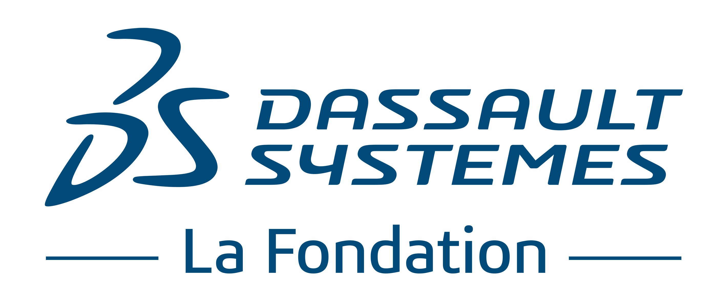

APPLICATION FORM

FOR

THE DASSAULT SYSTÈMES U.S. FOUNDATION

Organization’s name

Project title

Submission date

Reminder of the criteria for eligibility

The project must:

- Be consistent with The Dassault Systèmes U.S. Foundation’s (the “Foundation”) objective and purpose from Article III of the Foundation’s Certificate of Incorporation:

The nature of the business and purpose to be conducted or promoted by the Foundation are: To pursue exclusively educational and charitable purposes, including without limitation to inspire students and educators to develop innovative three-dimensional (3D) tools and content, to kindle enthusiasm in engineering and the sciences, and to provide instruction or training to individuals for the purpose of developing their capabilities.

- Fulfill the sponsorship criteria:

- The focus on a non-profit, non-commercial project intended to benefit the public

- The support of a recognized organization of general interest whose headquarters are located in the United States

The following will also be considered:

- the nature of the impact and leverage of the proposed action,

- the character of its innovative and inspirational model,

- its ability to integrate and value diversity, especially the diversity ratio between men and women,

- its national presence,

- its ability to involve and inspire employees of Dassault Systèmes,

- its metrics.

- Information regarding the organization requesting the participation of the Foundation

Name and title of the President, CEO or head of organization

Organization’s name

Organization Creation Date

Legal Status (organization must be non-profit)

Mission

Financial statements - please provide:
- Annual Report
- Statement of Financial Position
  - Or Balance Sheet
- Statement of Activities
  - Or Income Statement

Geographical coverage

Number of employees

Number of volunteers

Describe the expertise & prior experience of the organization

Are Dassault Systèmes employees already involved with the organization?

- Presentation of the project

Project Title

Project start date

Project end date

Name and title of the project manager

Address
Phone Number
Cell Phone
E-mail

Project scope

Education

Research

Heritage Preservation

Other:

Project description (15 lines max.)

Main objectives of the project

Describe/explain how this project is consistent with the mission of the Foundation. How will the funds be used? (please attach a detailed funding plan)

Beneficiaries (social category / age range / gender diversity / other)

Detailed schedule

Geographical scope of project

Expected results and indicators of success (quantity / quality)
e.g. number of students being trained, assessment grid

Communication plan & promotional tools
Please detail how you will advertise this project and the Dassault Systèmes US Foundation’s involvement in conjunction with the project (e.g. press release, video, flyers, posters, etc.)

- Project budget

Funding plan (budget, organizations approached for funding, amounts requested & granted, intended budget for Dassault Systèmes US Foundation Grant).

Please note that no funds granted by the Dassault Systèmes US Foundation to a project recipient shall be used by such recipient to purchase any products, licenses or other software produced or services provided by Dassault Systèmes.

What type of support are you requesting from the Foundation?

Please note that the Dassault Systèmes US Foundation does not approve multi-year grants at this time. Each organization, however, is entitled to submit as many project-specific submissions (each subject to review) as they wish.

Cash (amount)

Content (e.g. software)

Skills sponsorship (please include as much detail as possible)

Your organization agrees that any educational content (including but not limited to curriculums, lesson plans and teaching materials) created or developed by your organization in connection with any grant from the Dassault Systèmes US Foundation shall be reusable by and made accessible to other schools and organizations.

- Document check-list
Please provide a copy of:

Articles of Incorporation
501(c) non-profit status documentation
W-9
Annual Report
Statement of Financial Position (or Balance Sheet)
Statement of Activities (or Income Statement)
Funding Plan

Please send the completed application form and any attachments in PDF format to apply@lafondation3ds.us

